

Internal Assessment Resource

Geography Level 2

|  |
| --- |
| This resource supports assessment against:  Achievement Standard 91241 version 4  Demonstrate geographic understanding of an urban pattern |
| Resource title: London – population change over time |
| 3 credits |
| This resource:   * Clarifies the requirements of the standard * Supports good assessment practice * Should be subjected to the school’s usual assessment quality assurance process * Should be modified to make the context relevant to students in their school environment and ensure that submitted evidence is authentic |

|  |  |
| --- | --- |
| Date version published by Ministry of Education | October 2024  To support internal assessment from 2025 |
| Authenticity of evidence | Teachers must manage authenticity for any assessment from a public source, because students may have access to the assessment schedule or student exemplar material.  Using this assessment resource without modification may mean that students’ work is not authentic. The teacher may need to change figures, measurements or data sources or set a different context or topic to be investigated or a different text to read or perform. |

**Internal Assessment Resource**

Achievement Standard Geography 91241: Demonstrate geographic understanding of an urban pattern

Resource reference: Geography 2.2A v3

Resource title: London – population change over time

Credits: 3

Teacher guidelines

The following guidelines are supplied to enable teachers to carry out valid and consistent assessment using this internal assessment resource.

Teachers need to be familiar with the outcome being assessed by Achievement Standard Geography 91241. The achievement criteria and the explanatory notes contain information, definitions, and requirements that are crucial when interpreting the standard and assessing students against it.

Context/setting

This activity requires students to demonstrate understanding of an urban pattern within the context of the population growth of London over the past 400 years. Understanding of a pattern (spatial or temporal) is required. The variation in the pattern can be spatial and/or temporal. The population change that London has experienced needs to be explained.

The resource materials supplied with this assessment are sufficient for enabling students to answer successfully. If London has been the focus of the school-based learning programme, then information from that learning could also be incorporated into answers and would likely enhance the quality of them. Pre-teaching of geographic concepts would be required. Information about geographic concepts included within the assessment resources is that provided in the Geography Teaching and Learning Guide.

Teachers could adapt this assessment activity by using a different urban area to London as the context for the assessment – for example a New Zealand city or an overseas city other than London.

Conditions

This assessment activity will take place over 2 hours of in-class work.

The assessment is an individual one that is closed book and resource based.

Students could include information from class learning (prior learning) to support their answers.

Resource requirements

No additional resource materials are required. Prior learning information may be incorporated into answers.

If an urban area other than London were used as the assessment context then resource material similar to that provided for London would need to be provided by the teacher.

Additional information

None.

**Internal Assessment Resource**

Achievement Standard Geography 91241: Demonstrate geographic understanding of an urban pattern

Resource reference: Geography 2.2A v3

Resource title: London – population change over time

Credits: 3

|  |  |  |
| --- | --- | --- |
| Achievement | Achievement with Merit | Achievement with Excellence |
| Demonstrate geographic understanding of an urban pattern. | Demonstrate in-depth geographic understanding of an urban pattern. | Demonstrate comprehensive geographic understanding of an urban pattern. |

Student instructions

Introduction

This assessment activity requires you to demonstrate geographic understanding of a temporal pattern related to population change (change in population total) of London over time.

Teacher note: Reference material and resources that you may wish to use with your students are provided in appendix 1.

Integrate into your answers detailed specific case study information about London and its population growth using geographic terminology.

* You may further develop your answers through the use of visual information in the forms of maps and diagrams, and reference to elements, processes, events and perceptions related to the pattern of population growth. You may include information from prior learning about urban patterns and London to support your answers.

Task: Demonstrate a geographic understanding of the pattern of population change in London over time

Part 1

Describe the temporal pattern of population growth in London over the last 400 years – since 1600.

Explain the factors and/or circumstances that contribute to the pattern of population change.

Throughout your answers include geographic terminology and detailed, specific case study evidence.

Part 2

Describe, in detail any variation in the temporal pattern of population change in London.

Fully explain the factors and/or circumstances that have contributed to the temporal variation in the pattern of population growth.

Throughout your answers integrate geographic terminology and detailed, specific case study evidence.

Assessment schedule: Geography 91241 London – Population change over time

|  |  |  |
| --- | --- | --- |
| Evidence/Judgements for Achievement | Evidence/Judgements for Achievement with  Merit | Evidence/Judgements for Achievement with  Excellence |
| The student has demonstrated a geographic understanding of the population growth pattern of London.  The student has included evidence that:   * describes the temporal pattern of London’s urban population growth * explains the factors and/or circumstances that contribute to the pattern of urban population growth * includes geographic terminology and specific London-related evidence.   For example (partial extract only)  Since 1600 London’s population has grown from less than half a million to a total of over 7 million. There is a prediction the population will be over 8 million by the year 2031.  This growth in population has been the result of people moving to the city. People have been attracted by the job opportunities that London has. The Industrial revolution in the 19th century caused the biggest population growth because new manufacturing jobs in places close to the port of London becoming available. In the 20th century migrants have been attracted by work in London’s financial and tourism sectors.  London is seen by many people as the city ‘where things happen’ so London continues to attract migrants and is predicted to have a population of over 8 million by 2031. | The student has demonstrated an in-depth geographic understanding of the population growth pattern of London.  The student has included evidence that:   * describes, in detail, a temporal variation in the pattern of London’s urban population growth * explains, in detail, factors and/or circumstances that contribute to the temporal and/or spatial variation in the pattern of urban population growth * includes geographic terminology and detailed specific London-related evidence.   For example (partial extract only)  Since 1600 London’s population has grown from less than half a million to a total of over 7 million. There is a prediction the population will be over 8 million by the year 2031.  London’s pattern of population growth has not been a smooth one. There have been times of rapid growth especially between 1800 and 1939 but times of slow growth and even negative growth like between 1951 and 1991. This graph shows some of these changes (copy of graph Resource 2 is included by the student).  The variation in growth has been because of changes in job opportunities within London. In the 1800 – 1939 period there was a great growth in manufacturing and port related jobs due to the industrial revolution and London’s growth into a major world seaport. The effects of cumulative causation were at work as jobs and people attracted each other. The population of London grew from 1 million to over 8 million.  This growth did not continue. Between 1939 and 1991 London’s population declined. One reason for this is that the city became less attractive as a place to live because of pollution, poor housing and congestion. People moved to smaller towns and rural areas outside of London. Many of these people commuted to work in London but were not counted as being Londoners in the census statistics.  Since 2000 London’s population has been growing again and this growth is expected to continue. This is because London has more job opportunities and lower unemployment than other parts of the British Isles and countries of the European Union. In-migration has taken place as people are ‘pulled’ (attracted) to the city.  ‘Perception’ has been important in influencing the growth pattern of London’s population. If people see the city as a place that is vibrant and offering them opportunities for employment and a ‘good life’ then they will move to the city. This has happened recently as although Britain has been going through difficult financial times, London seems to offer more opportunities than other places. The 2012 Olympic Games has enhanced this positive image of London. | The student has demonstrated a comprehensive geographic understanding of the population growth pattern of London.  The student has included evidence that:   * fully explains the temporal variation in pattern of London’s urban population growth * fully explains the factors and/or circumstances that contribute to the temporal and/or spatial variation in the pattern of urban growth * integrates geographic terminology and specific and detailed London-related evidence.   For example (partial extract only)  Since 1600 London’s population has grown from 200,000 to over 7 million. The upward pattern of growth has not been steady and continuous. This graph shows how the population has changed (line graph drawn by student showing population change 1600–2031 is included).  The graph shows a slow pattern of growth between 1600 and 1800 followed by rapidly accelerating growth in the years after 1800 with the population exceeding 8 million by 1939.During this time London became a sort of magnet for migrants. People were attracted to work available in the developing manufacturing industries located around the port and alongside major road and rail routes. Another type of job were those in government and the financial sector. These jobs were connected with London being a capital city and world financial centre. The multiplier concept is important in explaining the rapid growth of London’s population. As the manufacturing and service sector jobs grew so more people moved to London. Manufacturing, services and people needed buildings – factories, offices and houses population – so lots of jobs in construction industries became available. People moved to London to take up these jobs. All these people needed schools, hospitals, and shops so again these provided employment and this meant more migration to London. This multiplier process caused an upward spiral of growth.  In the period between 1939 and 1991 the opposite process took place with London’s pattern of population growth reversing. The city had a population decline of over 1 million people in the second part of the 20th century. This reversed pattern of growth was caused by two main factors. First the city became less attractive as a place to live because of congestion, pollution and a loss of jobs. Many jobs were lost when the docks (port area) of London shifted downstream to nearer the mouth of the River Thames. The Docklands area of inner east London became a derelict area. A second cause of population decline was in some ways a ‘false decline’ People moved from London to rural towns and villages beyond the Green Belt (map included showing the Green Belt based on Resource 5). The rural lifestyle attracted these people. Many of these people commuted to work in London using the well-developed rail system. In many ways these people were still part of the London urban area but were not included as ‘living in London’ in the official census counts.  Since 1991 London’s population has returned to a pattern of growth and London has once again ‘pulled in’ migrants. This has been due to improvements in the economy of London and of the image the city has of being ‘a place where things happen’. Many inner city areas have undergone urban renewal with new offices, transport infrastructure and housing areas developed leading to a ‘multiplier effect’. The renewal and developments in the Lea Valley area of inner east London connected with the 2012 Olympic Games are an example of this revival. |

Final grades will be decided using professional judgement based on a holistic examination of the evidence provided against the criteria in the Achievement Standard.

**Appendix 1: Reference Material**

Resources

Resource 1: Greater London – population change 1600 - 2031

|  |  |  |  |
| --- | --- | --- | --- |
| **Year** | **Population total** | **Population total change: growth (+) or decline (-)** | |
| 1600 (estimate) | 200,000 | 1600 - 1700 (100 years)  1700 – 1801 (101 years)  1801 – 1851 (50 years)  1851 – 1901 (50 years)  1901 – 1951 (50 years)  1951 – 2001 (50 years)  2001 – 2031 (30 years) | + 250,000  + 550,000  + 1,551,000  + 3,859,000  + 1,687,000  - 1,1025,000  +1,657,000 (prediction) |
| 1700 (estimate) | 550,000 |
| 1801 (first official census) | 1,100,000 |
| 1851 | 2,651,000 |
| 1901 | 6,510,000 |
| 1939 | 8,615,000 |
| 1951 | 8,197,000 |
| 1971 | 7,453,000 |
| 1991 | 6,394,000 |
| 2001 | 7,172,000 |
| 2011 estimate | 7,754,000 |
| 2031 prediction | 8,829,000 |

Resource 2: Greater London population change 1890 -2010

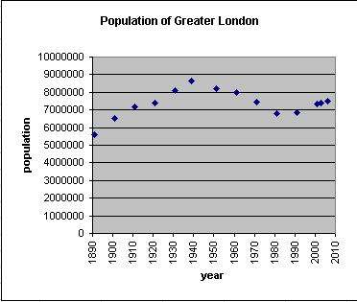

***Resource 3:***

**London 400 years of population history**

**1600 – 1800**

Until 1600, London although a capital city and major port was much less important than it is today. It was less important than other cities of continental Europe. Between 1600 and 1800 this situation changed. When England, Scotland Ireland united to form the United Kingdom London became capital of a bigger country than just England. Sea trade expanded with Asia and the Americas. London’s financial centre status began during this period with the setting up of the Bank of England. Increased trade and capital city and financial centre functions resulted in many jobs becoming available in London. People from other parts of the UK came to London to seek work and wealth. By 1800 London had become the world’s largest city and city of global importance. All this was before the age of urbanisation had really begun. The city and its importance were small by modern standards.

**1800 - 1900**

The last 200 years has seen big changes in the population total of London take place. The changes have not followed a smooth path.

London experienced a rapid and unprecedented level of growth throughout the 19th century due to the expansion of the British Empire and the impact of the Industrial Revolution. During this period the city expanded into a giant metropolis and became known as Greater London. The population grew from 1 million in 1800 to 6.7 million a century later. During this period, London became a global political, financial, and trading capital. In this position, it was largely unrivalled until the later part of the century, when Paris and New York began to threaten its dominance.

Comparing the beginning of the 19th century with the end, two starkly different cities can be seen both in terms of size and also in terms of technological advancement. In 1800 there were no railways, no cabs, no buses, no telegrams, no telephones, no gas, no electric light and no new Metropolitan Police. In 1900 all of the above existed.

19th century London was transformed by the coming of the railways and manufacturing. A new network of railways across the city and beyond allowed for the development of suburbs in neighbouring counties from which middle-class and wealthy people could commute to the centre. While this spurred the massive outward growth of the city, the growth of greater London also increased the class divide, as the wealthier classes moved to the suburbs, leaving the poor to inhabit the inner city areas. Manufacturing spurred on by the technological advances of the Industrial Revolution grew on sites close to transport – alongside the River Thames and in areas with good access to main roads and to railways that radiated out from the city. Trade through the port of London flourished as a result of the port serving a country that became the greatest manufacturing country in the world.

As the capital of a massive empire, London became a magnet for migrants from other parts of the United Kingdom and immigrants from the colonies and poorer parts of Europe. A large Irish population settled in the city during the Victorian period. At one point, Irish immigrants made up about 20% of London's population. London also became home to a sizable Jewish community, and small communities of Chinese and South Asians settled in the city.

**1900 - 2000**

London entered the 20th century at the height of its influence as the capital of the largest empire in history, but the new century brought many challenges.

London's population continued to grow rapidly in the early decades of the century, and public transport was greatly expanded. A large tram network was constructed and the first motorbus service began in the 1900s. Improvements to London's over ground and underground rail network, including large-scale electrification were progressively carried out.

The period between the two World Wars (1918 – 1939) saw London's geographical extent (area coverage) growing more quickly than ever before or since. A spiral of ‘upward growth’ became well established (Resource 4). The growth spiral was founded on government and service sector jobs in and around Central London, and on manufacturing industries producing a wide range of consumer, electronic and whiteware goods.

A preference for lower density suburban housing, typically detached and semi-detached, by Londoners seeking a more "rural" lifestyle, superseded Londoners' old liking for terraced houses. This was facilitated not only by a continuing development of the rail network, including trams and the Underground, but also by slowly widening car ownership. London's suburbs expanded into the neighbouring urban-rural fringes of Essex, Hertfordshire, Kent, Middlesex and Surrey. The population of London reached an all time peak of 8.6 million in 1939. In-migration from within the British Isles and from overseas continued to drive the growth.

In the immediate post-war years (after 1945) housing was a major issue in London, due to the large amount of housing, which had been destroyed in the war. The authorities decided upon high-rise blocks of flats as the answer to housing shortages. During the 1950s and 1960s the skyline of London altered dramatically as tower blocks were erected, although these later proved unpopular and many have now been demolished. In a bid to reduce the number of people living in overcrowded inner city housing, a policy was introduced of encouraging people to move into newly built new towns surrounding London beyond the green belt (Resource 5).

Population decline referred to in the next paragraph took place as counter-urbanisation was underway. People wanted to move away from the old, congested and polluted areas of the city for life in smaller towns and in rural areas. In many instances people moved into the rural areas just beyond the green belt. Many commuted in to London for work. These people often regarded themselves still as Londoners even though they had non-London addresses and were not counted as ‘being part of London’ in census and statistical data.

Greater London's population dropped steadily in the decades after World War II, from an estimated peak of 8.6 million in 1939 to around 6.8 million in the 1980s. London's status as a major port declined dramatically in the post-war decades (the 1960’s and 1970’s especially) as the old Docklands could not accommodate large modern container ships. The principal ports for London moved downstream nearer the mouth of the Thames estuary. Huge numbers of job losses occurred in London based port and port related jobs. The traditional port area alongside the River Thames in inner East London (Docklands) that had become largely derelict by the 1980s underwent massive redevelopment into luxury apartments and high rise offices from the mid-1980s onwards. Re-urbanisation was underway.

Just as technology changes in shipping lead to changes in the London Docklands so changes in aircraft technology impacted on tourism. This was important because London has always been a tourism hub. The increase in worldwide mobility meant quick and relatively cheap access could be gained to London by tourists from Europe, North America, the Middle East and Asia. Mobile affluent people travelling in huge numbers to London meant a big growth in London based tourism related jobs took place. Changes in transport technology had the opposite impact on tourism to that on the London docks.

Higher job availability and lower unemployment than that found in other parts of the British Isles and other European countries were factors that led to revival of in-migration to London. Push-pull factors influenced migration patterns within counties of the growing European Union where border controls no longer artificially inhibited population movement.

**2000 and beyond**

The population revival of London that began in the 1980’s, encouraged by strong economic performance and an increasingly positive image, has been predicted to continue into the 21st century with a population of 8.1 million expected by 2016, and continuing to rise thereafter. The economic, political and cultural supremacy of London results in the gravitational pull that London has on people – it is seen as the city “where things happen”. The 2012 Olympic Games can be seen as one example of this. The Olympics with venues and associated facilities concentrated in the depressed areas of inner east London around the Lea Valley has resulted in massive redevelopment of this area. Short term construction and tourism jobs have resulted but medium and longer term regeneration of this area will occur as the Olympic athletes’ village will be turned into 3,600 affordable housing apartments and stadiums and facilities like the aquatic centre become community assets. Other Olympic facilities will be converted into lifelong learning centres for the east London community with nursery and primary and secondary schools, and the conversion of the media and press centre into a creative industries centre for east London. The other aspect of ‘Olympics related regeneration’ will be from the improvements made to public transport in the area – especially rail network.

Nearness to work and avoiding the nightmare of commuting has become the attraction for highly skilled and well-educated service and government sector workers, especially in finance and marketing, to once again live within ‘inner London’ districts close to the city centre.

***Resource 4:* Multiplier Effect or Cumulative Causation**

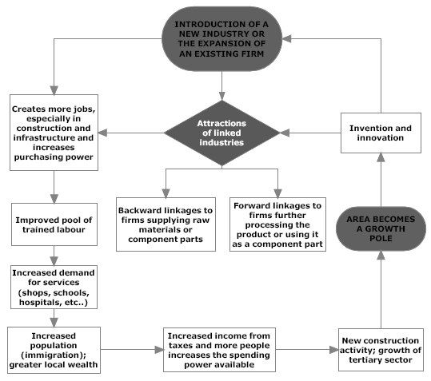

The introduction of a new industry or the expansion of an existing industry in an area also encourages growth in other industrial sectors. An upward spiral of growth is created.

Money invested in an industry helps to create jobs directly in the industry, but it also creates jobs indirectly elsewhere in the economy. New industrial development, for example, requires construction workers who themselves require housing, and services such as schools and shops. An increased demand for food will benefit local farmers who may increase their spending on fertilizer.

Workers employed directly in the new industry increase the local supply of skilled labour, attracting other companies who benefit from sharing this labour pool. Other companies who supply components or use the new industry's products are attracted to the area to benefit from reduced transport costs. Spin-off effects include new inventions or innovations that may lead to further industrial development and new linkages.

***Resource 5:* The Green Belt and future planning**

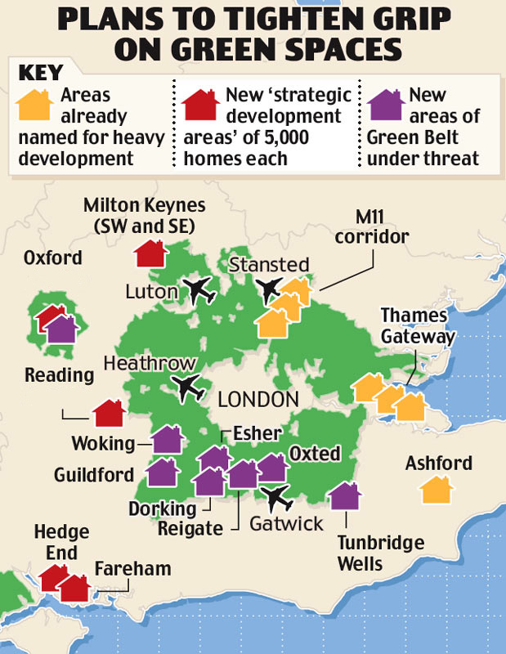

**The green belt surrounding London is shown as green shading on this map. The area is under threat from major development proposals for new housing and new industrial development for 21st century London.**

**What is the green belt?**

Green belts are a planning tool, first introduced for London in 1938. Councils were urged to introduce green belts where they wanted to restrict urban growth. Green belts aim to stop urban sprawl and the merging of settlements, preserve the character of historic towns, protect the countryside and encourage development to locate within existing built-up areas. Richard Bate, of planning consultancy Green Balance, says the primary function of a green belt is to "encourage development to go to the places where it will do most good and to discourage it in places where it will do quite significant harm".

**Concepts in geography**

**Environments**

May be natural and/or cultural. They have particular characteristics and features, which can be the result of natural and/or cultural processes. The particular characteristics of an environment may be similar to and/or different from another.

**Perspectives**

The way people view and interpret environments. Perspectives and values may be influenced by culture, environment, social systems, technology, and economic and political ideology. They may influence how people interact with environments and the decisions and responses that they make.

**Processes**

A sequence of actions, natural and/or cultural, that shape and change environments, places and societies. Some examples of geographic processes include erosion, migration, desertification and globalisation.

**Patterns**

May be spatial: the arrangement of features on the earth’s surface; or temporal: how characteristics differ over time in recognisable ways.

**Interaction**

Involves elements of an environment affecting each other and being linked together. Interaction incorporates movement, flows, connections, links and interrelationships. Landscapes are the visible outcome of interactions. Interaction can bring about environmental change.

**Change**

Involves any alteration to the natural or cultural environment. Change can be spatial and/or temporal. Change is a normal process in both natural and cultural environments. It occurs at varying rates, at different times and in different places. Some changes are predictable, recurrent or cyclic, while others are unpredictable or erratic. Change can bring about further change.

**Sustainability**

Involves adopting ways of thinking and behaving that allow individuals, groups, and societies to meet their needs and aspirations without preventing future generations from meeting theirs. Sustainable interaction with the environment may be achieved by preventing, limiting, minimizing or correcting environmental damage to water, air and soil, as well as considering ecosystems and problems related to waste, noise, and visual pollution.

**Other concepts relevant to the population growth of London include:**

Location

Accessibility

Globalisation

Cumulative causation

Perception